**Software Design**

A00211953

Brain Mahon

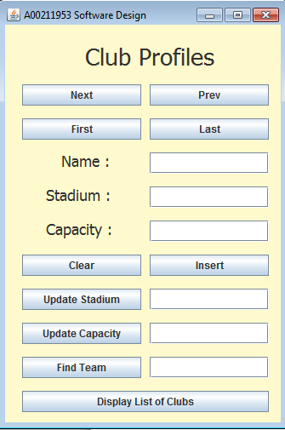

# Application Functionality

The functionality of this application allows you to navigate and interact with a list of club profiles. The navigation buttons ‘Next’, ‘Previous’, ‘First’ and ‘Last’ allow you to look through a list of twenty list entries. The results are stored in the ‘Name’, ‘Stadium’ and ‘Capacity’. For this I used a HashSet and then linked it converted it to the form of an ArrayList so that the results would be displayed in the same order they were entered. The ‘Clear’ button clears the three main text fields.

The ‘Insert’ button adds a new entry to the end of the list, it is also conditioned to display errors in the form of alert messages if the club already exists in the list or if text fields are empty. An alert to notify a successful entry is also displayed.

‘Update Stadium’ and ‘Update Capacity’ buttons have the same functionality. If the name displayed exists in the list, and there is a valid entry in the update field then the club profile will be updated, the textbox will be cleared and a successful alert message will be displayed. Otherwise an alert of invalid entry will be displayed.

If the ‘Find Team’ button is pressed the iterator will run through the list and try to find a match for the input in the text field. If successful an alert will be displayed and the club will be returned. Alerts will also be displayed on unsuccessful searches.

The function of the ‘Display List of Clubs’ button is to get the list of all club names in the list and display them in the java console. I didn’t figure out how to complete this function and could only return the object HashCode.

# Key code and Screenshots

HashSet to ArrayList



Populated List

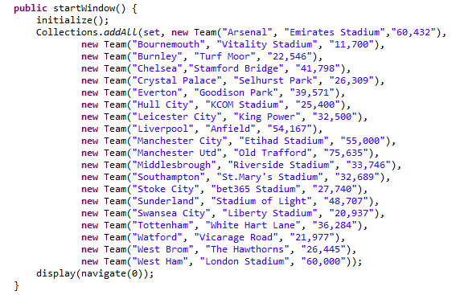

Previous and Next Buttons

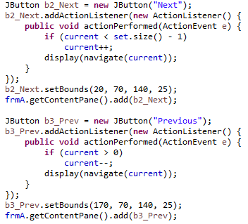

First and Last Buttons

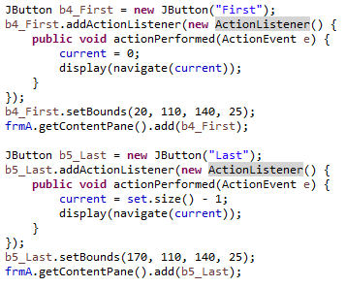

Insert Button

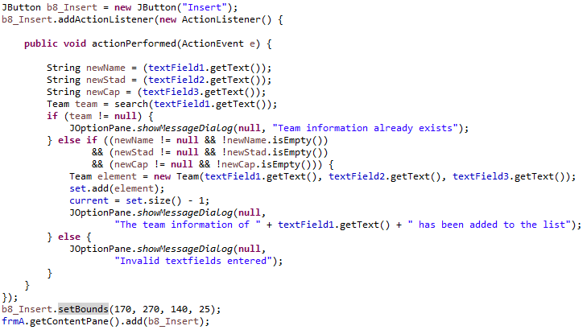

Update Capacity similar to Update Stadium

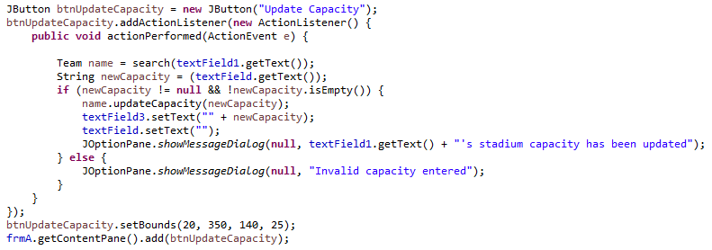

Search Button

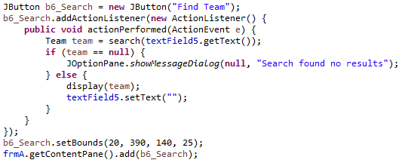

Display List Button

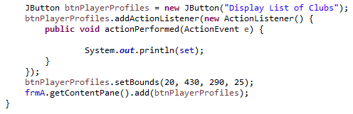

Search and Navigate Methods

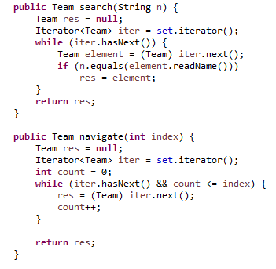

# Project Reflection

Looking back on the project, if I were to do this project again I would probably make a more complex GUI interface. I kept it simple as I wasn’t very confident in what I would be able to achieve in the timeframe, but as I worked through this project I learned a lot of things that I would be able to implement if given the same task again. One area which I found difficult was when trying to display the list of names in the console log, I could only display the object Id because I couldn’t figure out how to separate the elements of the object, however I did read a lot of information on it and attempted to do it in a few different ways including iterating through the list and trying to return all. Another part that I spent a lot of time on was converting the HashSet to an Array, my objective was to display results in alphabetical order which isn’t possible with HashSet, not knowing how to achieve this I had to do a lot of research and learning about HashSets, TreeSets, HashMaps and TreeMaps so that I could decide which one I should use. The solution ended up being very simple by just converting it to an ArrayList.